<https://dist.nuget.org/win-x86-commandline/latest/nuget.exe>

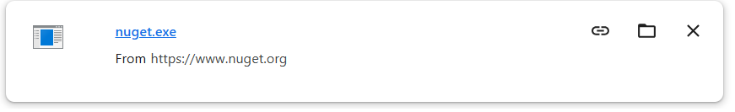

Set path to the environment variable

To set the NuGet path to the environment variable, you need to specify the folder ({any folder name}) that contains NuGet's executable (nuget.exe)

**Step 2: Add NuGet Path to Environment Variables**

1. **Open the Start Menu** and type Environment Variables.
2. Click **Edit the system environment variables** or **Edit environment variables for your account**.
3. In the **System Properties** window, click on the **Environment Variables** button.
4. Under the **System Variables** section (for all users) or **User Variables** (for just your user), click on **New** to add a new environment variable.
   * **Variable name**: NUGET_PATH
   * **Variable value**: The path to the folder that contains nuget.exe. For example:  
     C:\Program Files (x86)\NuGet
   * Alternatively, if you want to set it globally (for all users), you can modify the **Path** variable directly:
     1. Find the **Path** variable in the **System Variables** section, and click **Edit**.
     2. Add the path to the folder containing nuget.exe, e.g., C:\Program Files\NuGet.
5. Click **OK** to close all windows.

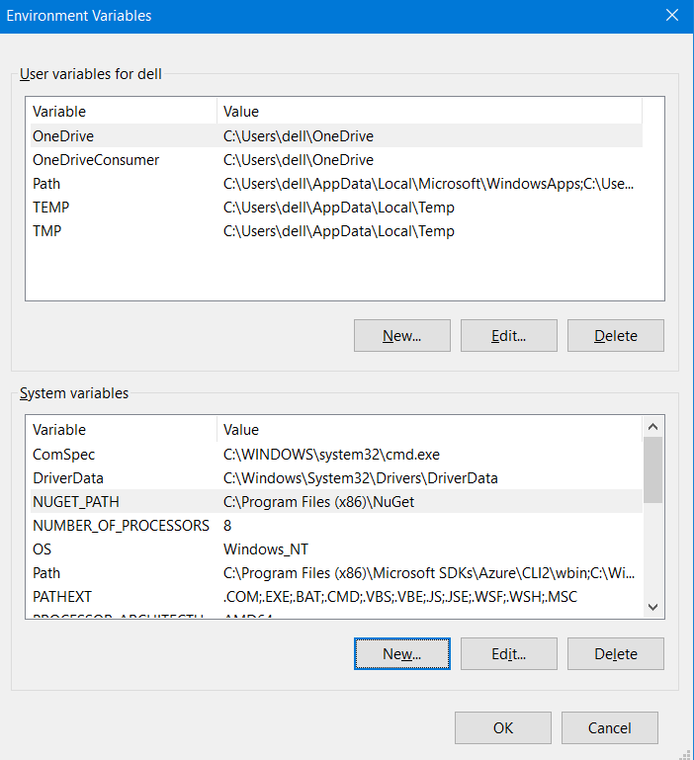

**Step 3: Verify the NuGet Path**

1. Open a **Command Prompt** (cmd) or **PowerShell** window.
2. Type the following command to check if NuGet is recognized:

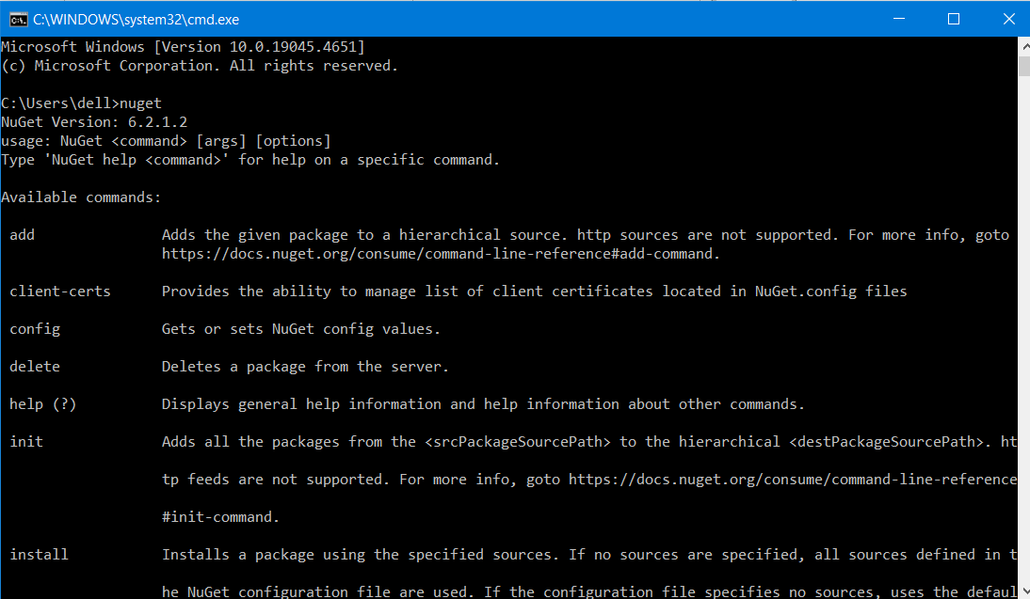

**Step 4: Build ESGenesisCore Solution in release mode.**

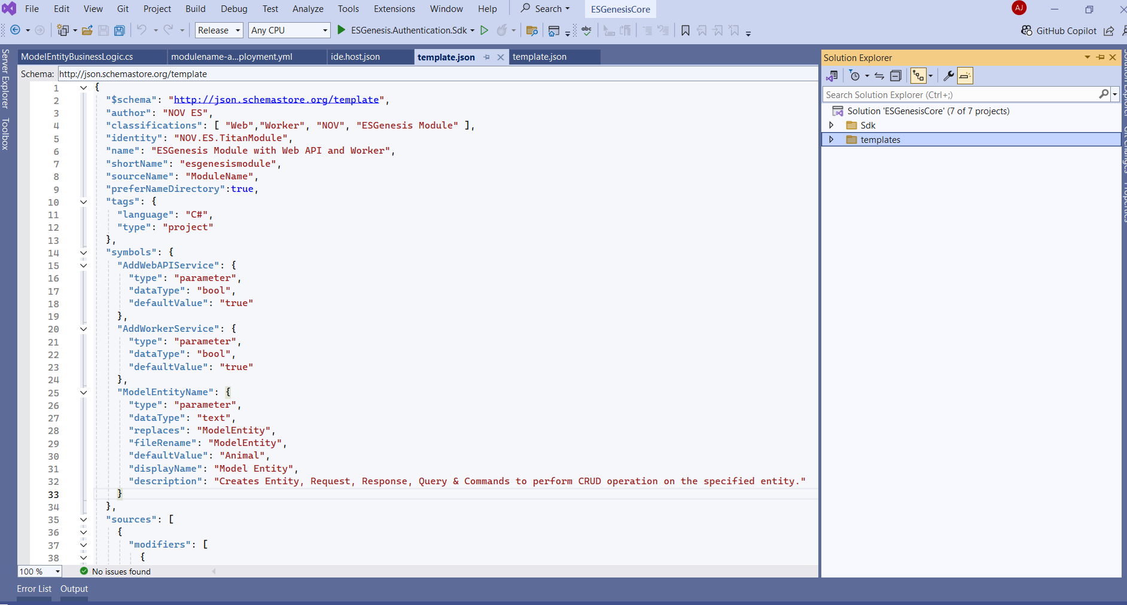

* + 1. **navigate to SDK folder then src folder**

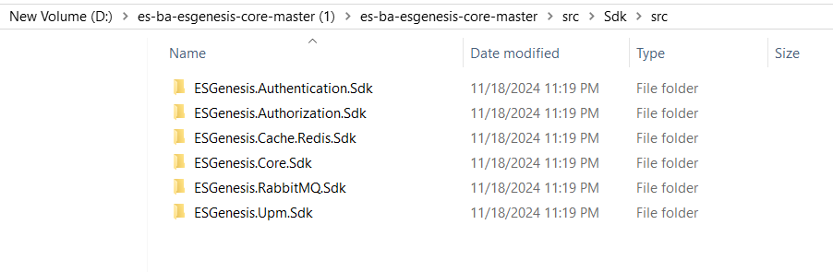

* + 1. **Navigate to ESGenesis.Authentication.Sdkfolder and In release folder able to see nuget packages**

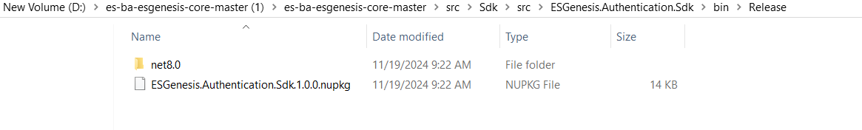

**Step 5: Create a Local Folder(ESGenesisNugetSource) for NuGet Packages.**

**Step 6: Create folder structure inside ESGenesisNugetSource**

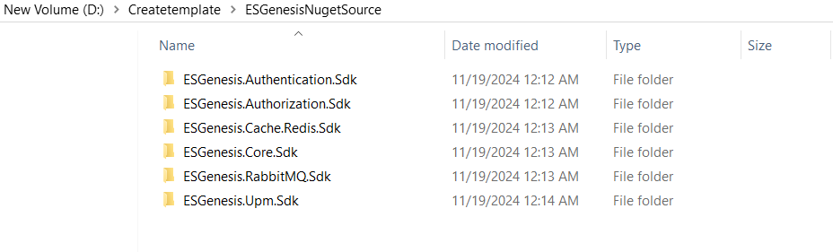**2. Copy both files from release folder to each source folder.**

**Step 7 : Create Folder ESGenesisNugetRepo**

1. **Open Command prompt**

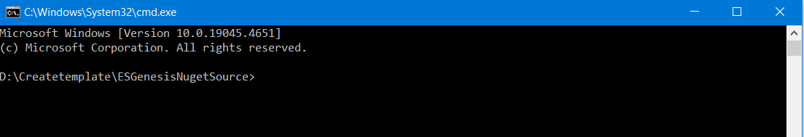

1. **Run Command Nuget init <srcPackageSourcePath> <destPackageSourcePath>**

**srcPackageSourcePath: “D:\Createtemplate\ESGenesisNugetSource”**

**destPackageSourcePath : ESGenesisLocal**

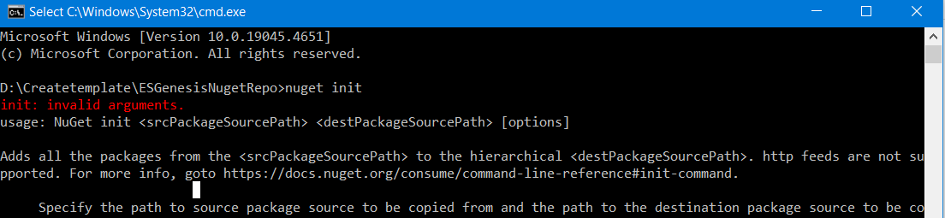

**Output :**

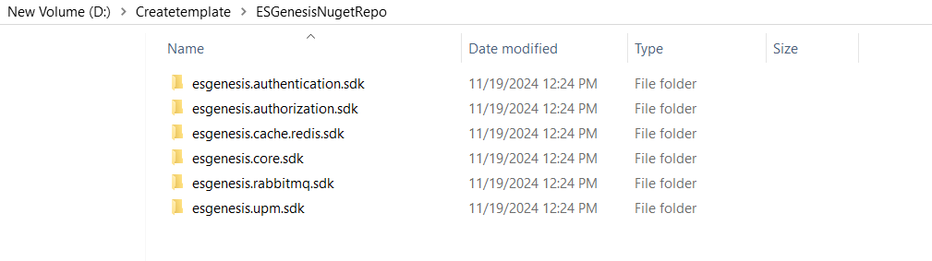

Step 8 :

